Practice Packet: Activity 2.2
This document demonstrates the process of completing a Drill Down in SWIS in order for individuals to practice creating precise problem statements and generating solutions.
Author: Michigan’s Integrated Behavior and Learning Support Initiative (MIBLSI)
Version: 1.0
Date: May 2018

Scenario:
You are a Fifth Grade Team at a K-7 building. Your grade level team is sitting down to look at the data more closely during your monthly grade level meeting.

Referrals by Grade Level
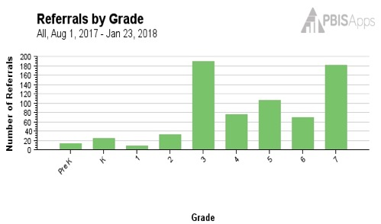

SWIS Drill Down for Fifth Grade
Fifth Grade Referrals by Problem Behavior
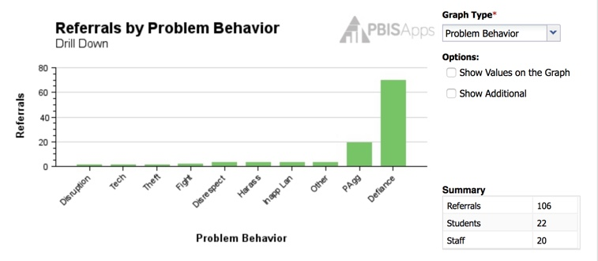
Fifth Grade Referrals for Defiance by Location
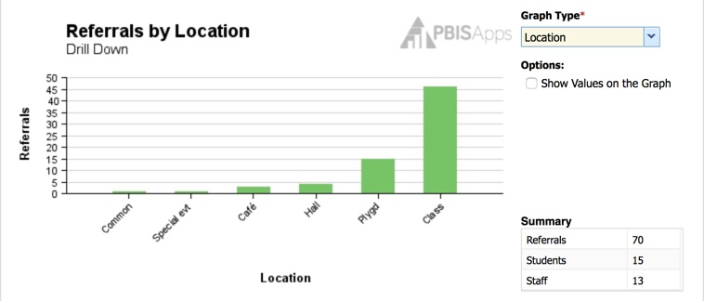

Fifth Grade Referrals for Defiance in the Classroom by Students
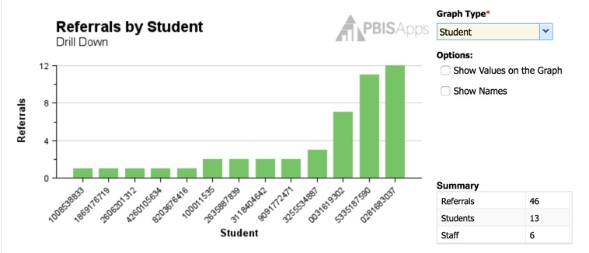
Fifth Grade Referrals for Defiance in the Classroom by Day of the Week
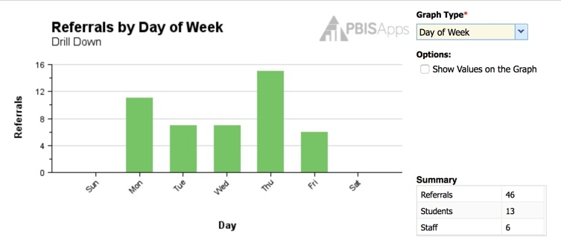

Fifth Grade Referrals for Defiance in the Classroom by Time of Day
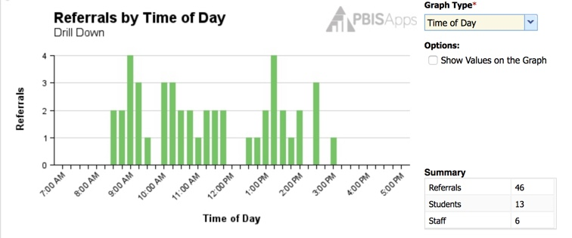
Fifth Grade Referrals for Defiance in the Classroom by Perceived Motivation
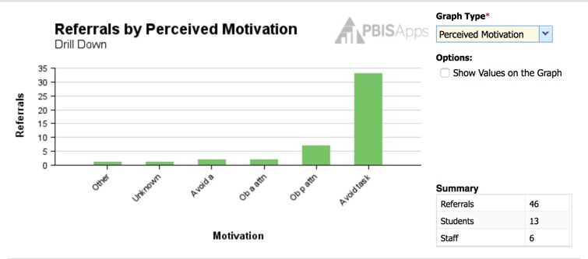

Grade Level Planning

Step #1: Problem Identification (What is the problem?)
What is your SWIS data indicating?

Step #2: Problem Analysis (Why is it happening?)
Organize your Precise Problem Statement using this chart
Drill Down Questions | Drill Down Data
What is the problem behavior?
Where is the problem behavior happening?
Who is engaged in the behavior?
When and how often is the problem behavior likely to occur?
Why is the problem sustaining?
Insert SMART Behavior Goal:

Step #3: Plan Development
Prevent | Teach | Respond

Step #4 Plan Implementation
Record specific actions items needed to implement this plan
Action Item | Who Will Do It? | By When? | Status
Record the specific actions needed to evaluate this plan
How will we know if our actions are having the desired impact? What data will we use? | Who will gather the data? | How often will it be gathered?

Michigan’s Integrated Behavior and Learning Support Initiative (MIBLSI) is a Grant Funded Initiative (GFI) funded under the Individuals with Disabilities Education Act (IDEA) through
the Michigan Department of Education.

