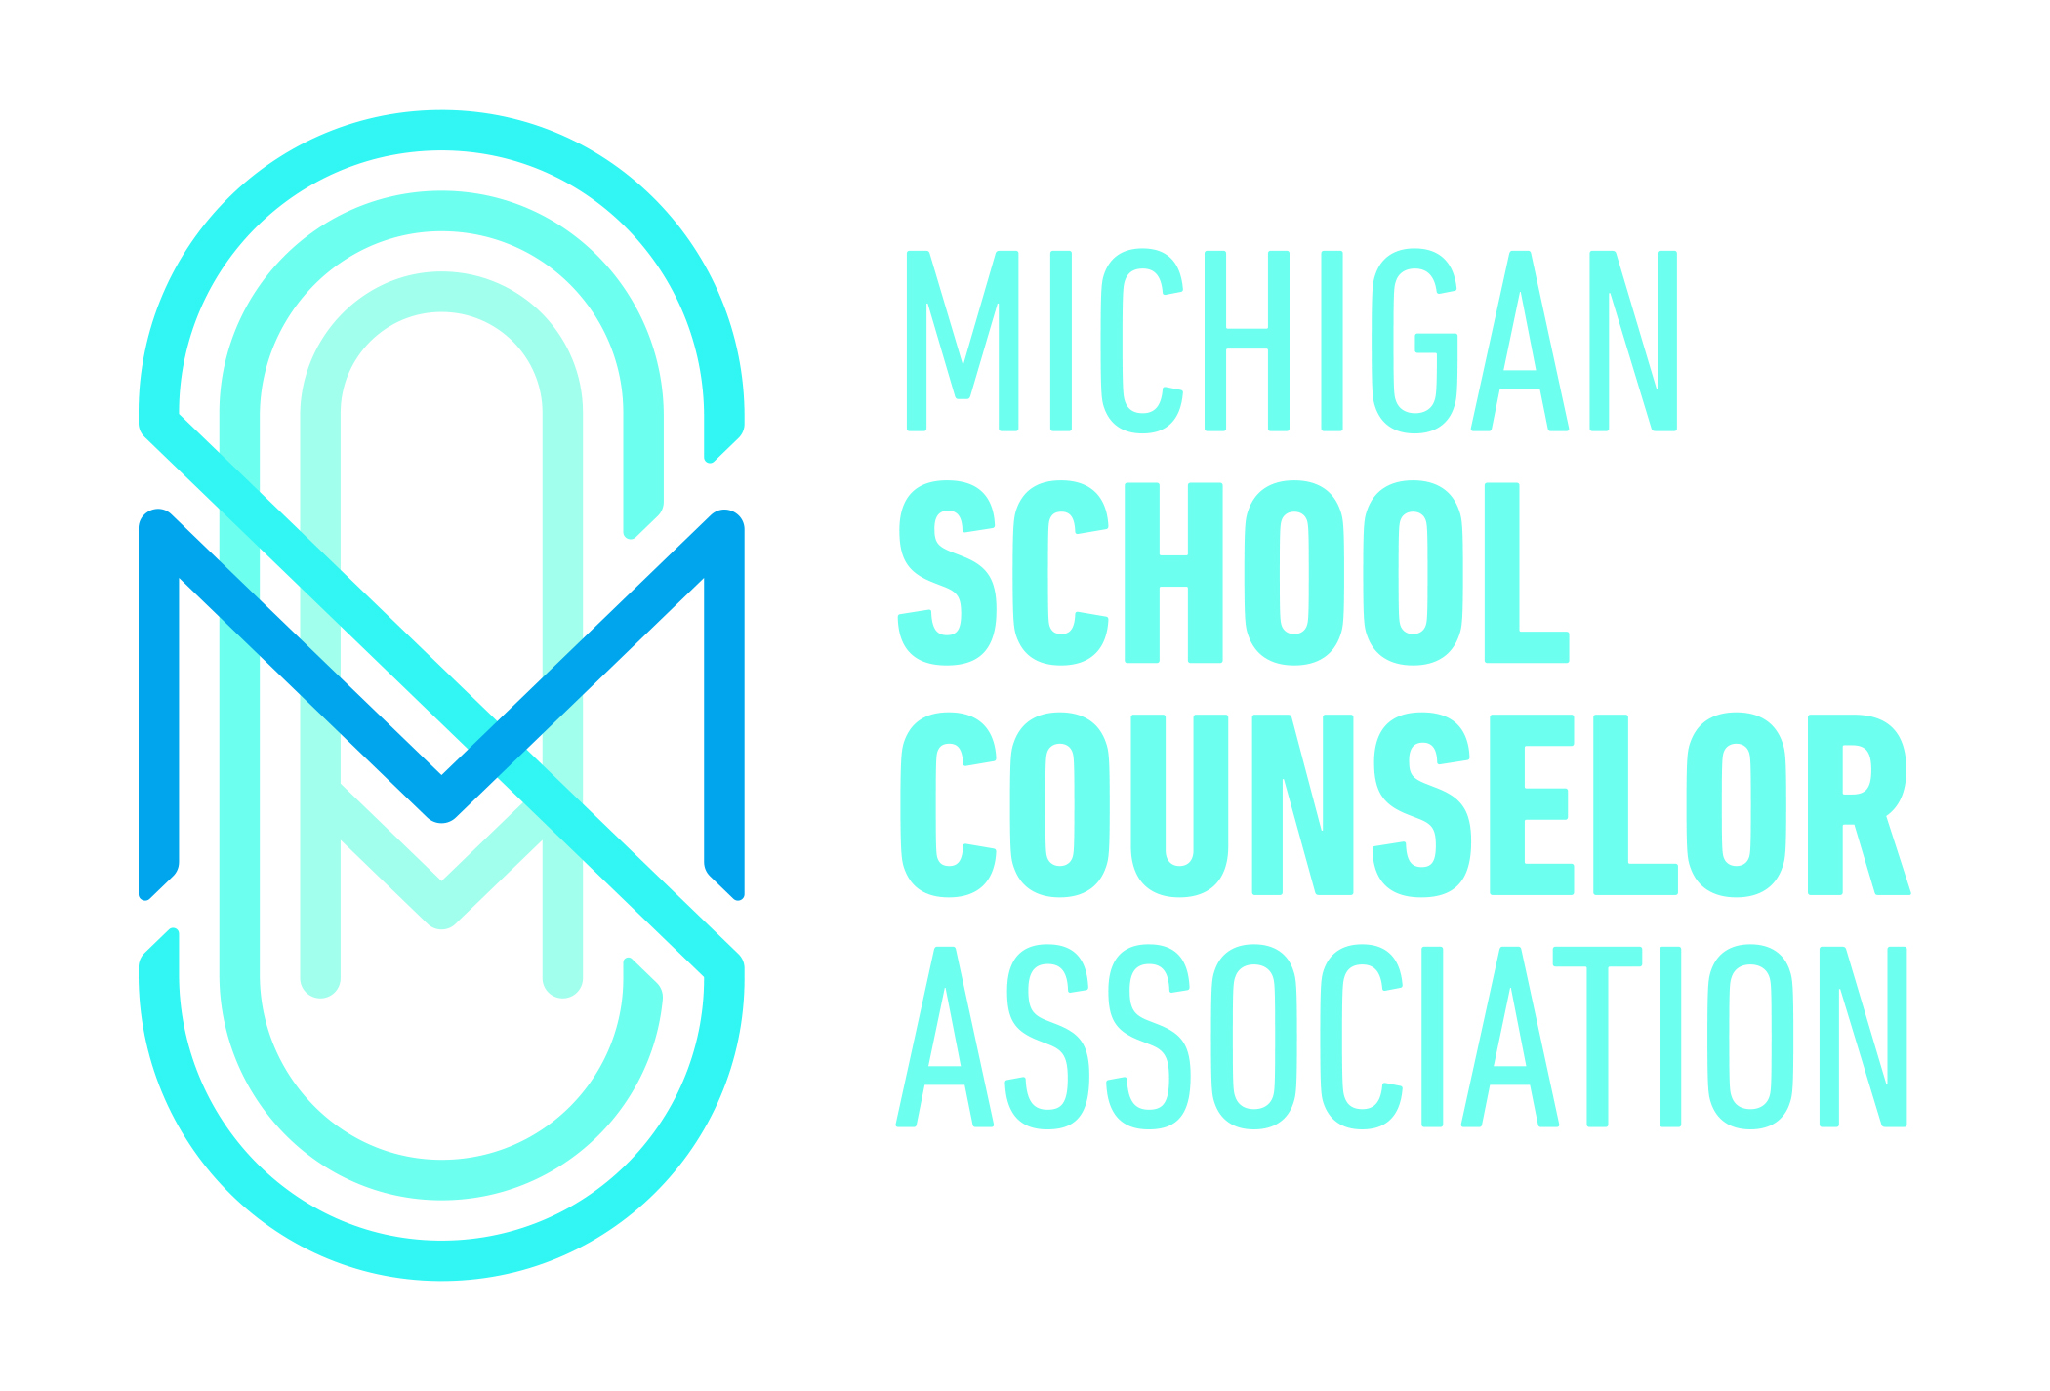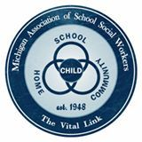

The Michigan Association of School Psychologists (MASP), the Michigan School Counselor Association (MSCA), and the Michigan Association of School Social Workers (MASSW), as participants in the Michigan School Mental Health Coalition, speak as one voice in support of the Michigan State Board of Education (SBE) draft guidance document, "Safe and Supportive Learning Environments for Lesbian, Gay, Bisexual, Transgender, and Questioning (LGBTQ) Students".

School psychologists, school counselors, and school social workers have an ethical obligation to advocate for and affirm LGBTQ students. We have resources and effective strategies to minimize the negative statistics associated with LGBTQ students. While our approaches differ slightly, we work in harmony and partnership to help LGBTQ students be empowered and supported to become visible and strong.

Research clearly identifies LGBTQ youth as at-risk for a number of negative outcomes. When compared to youth who are heterosexual, youth who identify as LGBTQ or those who are gender nonconforming are more likely targeted for harassment and discrimination. For example, when over 7,000 LGBTQ students nationwide were surveyed regarding their school experiences, 84% reported being verbally harassed, 40% reported being physically harassed, and 18% reported being physically assaulted at school within the past year based on actual or perceived sexual orientation (Kosciw, Greytak, Diaz, & Bartkiewicz, 2010). While LGBTQ youth appear to experience higher levels of mental health and academic difficulties, school-based social situations like victimization and lack of support are frequently related to these heightened risk levels (Bontempo & D’Augelli. 2002; Goodenow, Szalacha, & Westheimer, 2006). It is thus imperative that we assist Michigan’s schools in adopting and implementing the State Board of Education guidelines which will ensure that all students receive a quality educational experience and support them in striving to reach their potential.

As mental health professionals, most often we are the first line intervention for all young people in schools today. Our work centers on helping young people become responsible and respectful while always providing them a personal, social, emotional, and physical safe space in which to learn.

The National Association of School Psychologists (NASP) supports that all youth have equal opportunities to participate in and benefit from educational and mental health services within schools regardless of sexual orientation, gender identity, or gender expression. The School Social Work Association of America also recognizes the importance of a safe school environment for all students, the increased physical and mental health risks faced by GLBTQ students and their right to attend school without fear of threat, harassment or denial of their civil rights. The American School Counselor Association (ASCA) has adopted a position statement on supporting LGBTQ youth, their risks and unique struggles, and the role of professional school counselors to support them and respond effectively to meet their needs so they feel valued, welcomed, and safe on school campuses.

MASP, MSCA and MASSW have worked together on the Michigan School Mental Health Coalition to promote policies, programs and services that address the mental health and well-being of students in Michigan’s schools; the deliberations and guidance of the Michigan State Board of Education are essential to address and resolve issues impacting LGBTQ young people. The adoption by the State Board of Education of the Statement and Guidance on Safe and Supportive Learning Environments for Lesbian, Gay, Bisexual, Transgender and Questioning (LGBTQ) Students will serve to promote the positive and respectful school climate that supports healthy development and improved educational outcomes for all of our students.

Michigan Association of School Psychologists (MASP)
Michigan School Counselor Association (MSCA)
Michigan Association of School Social Workers (MASSW)

May 6, 2016

